Here a screenshot of city_functions

Here’s a screenshot of test_cities

Here’s a screenshot of test cities failing

Here’s a screenshot of city_country with population becoming optional

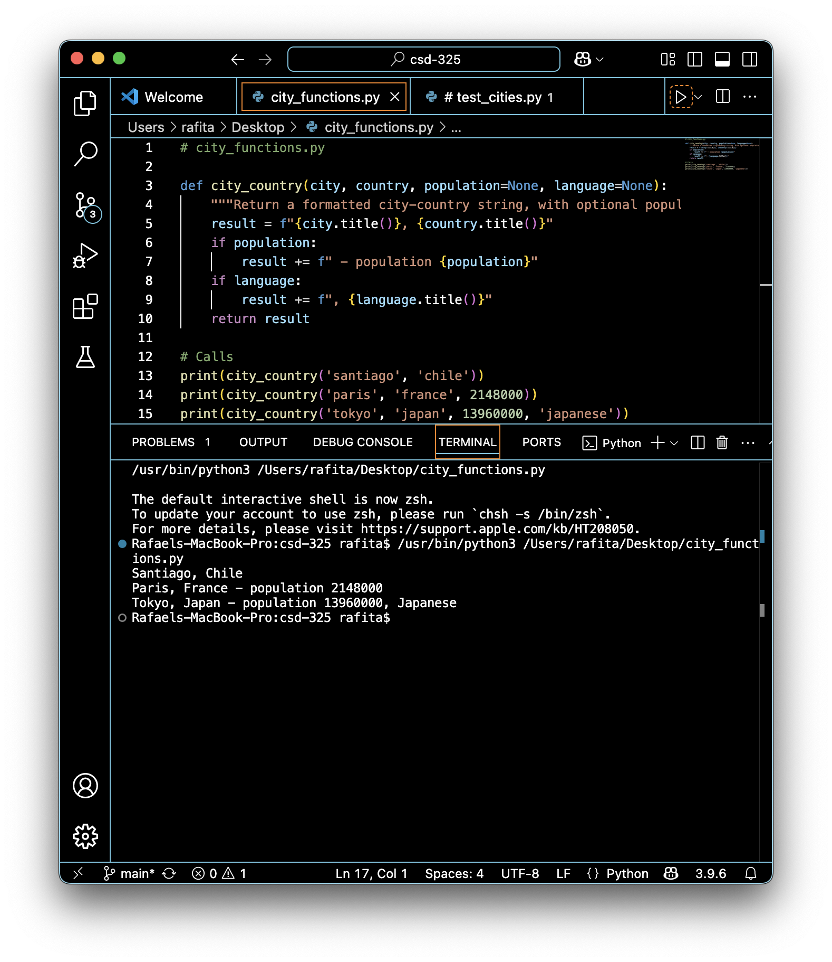

Here’s a screenshot of city_country and modifying the code to require language

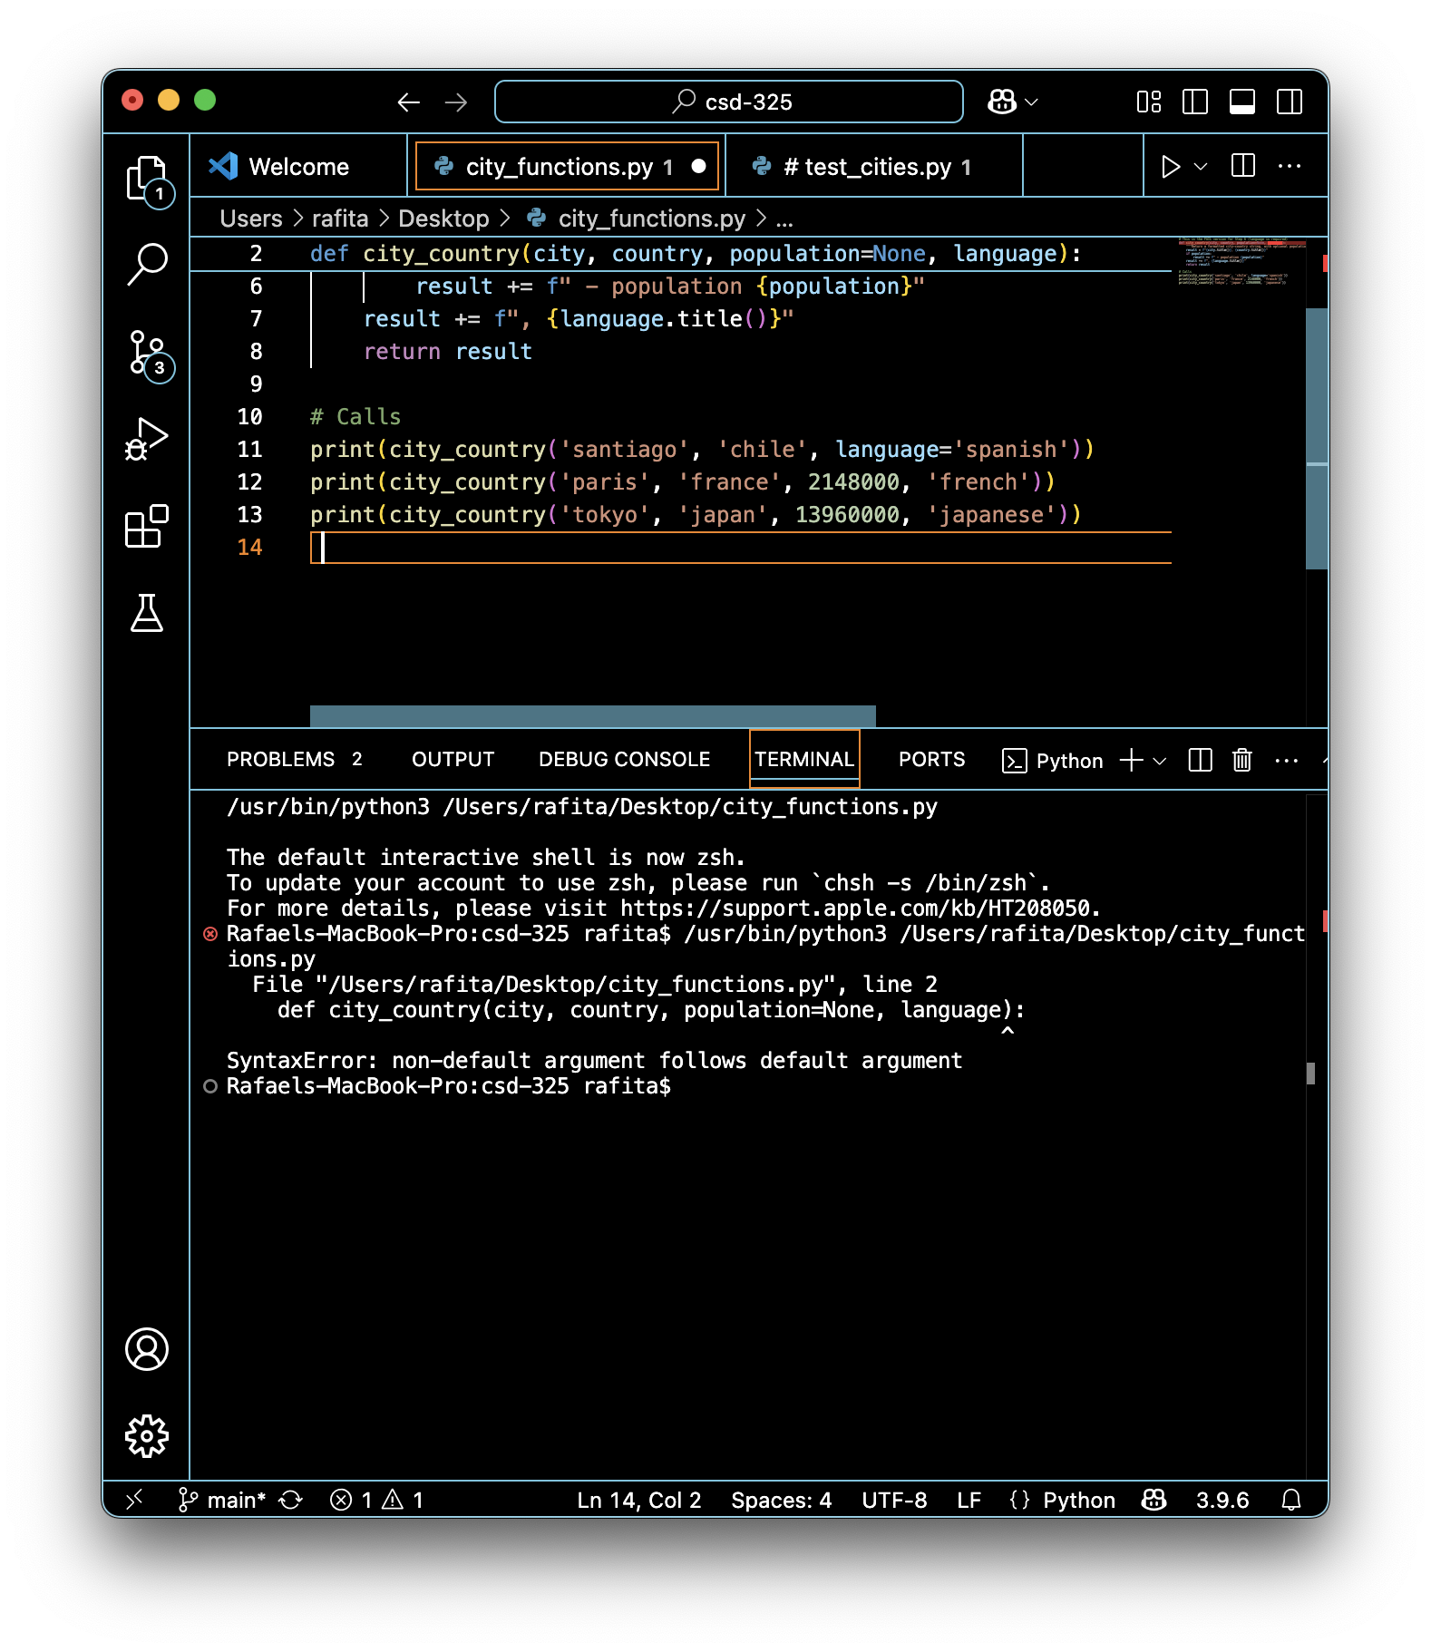

Here’s a screenshot of language becoming optional:  
